**Lesson 5 Explanation II**

**Consequential and Conditional Explanations**

**Lesson objectives:**

* Get to know what consequential and conditional explanations are
* Analyze the sample texts of consequential and conditional explanations
* Practice in writing the two types of explanation
* Learn to use evaluative language for critique

1. **Review**

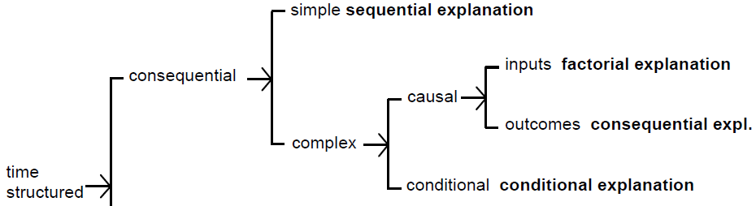

Stages: Phenomenon + Explanation

1. **Consequential explanations**

A single event may have two or more consequences.

**Sample Text 1:** **Woodlands of the South**

*In southern Australia the woodlands have been cleared to plant crops like wheat and other cereals. Sheep and cattle are grazed on introduced pastures. When the land was first cleared small clumps of trees or single trees were left for shade. Today these trees are reaching the end of their lives and dying.*

*The clearing of the trees has caused problems in using the land for farming. Without trees the land has been eroded by wind and rain. Today farmers are replanting the trees to try to stop this erosion.*

*Animals like the common dunnart (一种袋鼠) rely on the fallen logs for shelter. The logs of old trees have hollows in them and the small animals of the woodlands hide in these. If these logs are cleared and removed the animals no longer have places to shelter.*

*[Scots and Robinson 1993:114] (Genre Relations,* p. 149*)*

**Analysis:**

|  |  |
| --- | --- |
| **Phenomenon** *(cause)* |  |
| **Explanation** *(effects)* |  |
| tree death |  |
| soil erosion |  |
| habitat loss |  |

1. **Conditional explanations**

Effects may vary depending on variable conditions.

**Sample Text 2: Predator and Prey Population Numbers**

*Population size of one species can be affected by the size of the population of another species. This is true in the case of a predator species and the prey species on which it feeds. Over time, several outcomes are possible:*

*• If the predators are absent, the prey population will increase exponentially but will eventually ‘crash’ when its numbers become too high to be supported by the food resources in the habitat.*

*• If the prey population is too small, the predator population will starve and die.*

*In some cases, cycles of ‘boom-and-bust’ can be seen in both populations, with the peak in the predator population occurring after the peak in the prey population. Why?*

*[ Kinnear & Martin 2004：15] (Genre Relations,* p. 151*)*

**Analysis:**

|  |  |
| --- | --- |
| **Phenomenon** |  |
| **Explanation** |  |
| predators |  |
| prey |  |
| both |  |

**Sample text 3: Buoyancy and Density**

*If the object is completely submerged，it displaces its own volume of fluid. The weight of displaced fluid, and therefore the upthrust, will depend on the density of the fluid.*

*If the density of the fluid is less than the average density of the object, the weight of the displaced fluid will be less than the weight of the object and the object will sink.*

*If, on the other hand, the density of the fluid is greater than the average density of the object, the weight of the displace fluid will therefore exceed the weight of the object. The net upward force will then cause the object to rise to the surface where it will float.*

**Analysis:**

|  |  |
| --- | --- |
| **Phenomenon** |  |
| **Explanation** |  |
| Phase 1 (condition 1) |  |
| Phase 2 (condition 2) |  |

1. **Language Focus:** **Evaluative language**

Evaluative language is positive or negative language that judges the worth of something. It includes language to express feelings and opinions, to make judgments about aspects of people such as their behaviour, and to assess quality of objects such as literary works.

1. **Practice**

**Exercise 1:** Read the following text and answer the questions.

1) What type of explanation does the passage belong to?

2) Can you analyze the implication sequence of the paragraph?

Seasons of the Earth

*…*

*As a result of the tilt of the Earth's axis the southern hemisphere is inclined towards the sun in December and away from the sun in June. When the southern hemisphere tilts towards the sun, it receives more of the sun's rays at an angle closer to 900 and it experiences summer. During this time the northern hemisphere points away from the sun and is experiencing winter. When the southern hemisphere tilts away from the sun, most of the sun's rays strike the Earth obliquely and their heating effect is less. During this time the southern hemisphere has its winter. The northern hemisphere at the same time points toward the sun and has its summer.*

**Exercise 2: Read the following text and answer the questions.**

1. What type of explanation does the passage belong to?
2. How many consequences are caused by overeating?
3. Can you think of some other behaviors and their bad effects? Write a short passage about the consequences caused by that bad habit imitating the passage above in about 300 words

**Overeating and its consequences**

*Overeating means eating regularly when not hungry.* ***Overeating is not a specific diagnosis of any sort but may rather refer to a discrete incident of eating too much such as during holidays, celebrations, or while on vacation, or it may refer to habitual excessive eating.***

*People who engage in overeating regularly tend to eat when not hungry and may eat alone because they are embarrassed about the portions of food they are consuming. In addition, they may spend exorbitant amounts of time fantasizing about their next meal. Another sign that overeating has become a problem is if excessive amounts of money are wasted on food. In general, people who overeat are overweight or obese though people with normal body weights may overeat from time to time as well.*

*The long term consequences of chronic overeating may include high cholesterol, diabetes, heart disease, hypertension, depression, kidney disease and stroke. It may also result in psychological stresses, anxiety, isolation, and low self-esteem. However, treatment and support is available for those who habitually overeat and* [*recovery*](http://www.eatingdisordersonline.com/recovery/index.php) *is possible.*

**Exercise 3:** Group work. Oral/Written topics. Remember to include the stages of both phenomenon and explanation. Group members need to work together to finish the task and one student should report the group work to class.

Topic 1: What would be the possible effects of the rising costs of college education? (Consequential)

Topic 2: What are the consequences of procrastination (拖延症)? (Consequential)

Topic 3: Can you explain the relationship between marriage/child rearing and career for women? (Conditional)

Topic 4: Elaborate the function of using punishments and praises in children’s education. (Conditional)

**Exercise 4:** Rate the adjectives by using the scale. Use the sample sentence to guide your decision.

++ very positive + positive 0 neutral A ambiguous - negative - - very negative

*In this ______ study, the authors attempt to show that domesticated animals are in some way just as responsible as automobiles for our current CO2 imbalance.*

____ unusual ____ limited ____ ambitious ____ modest

____ small ____ restricted ____ important ____ flawed

____useful ____ significant ____ innovative ____ interesting

____careful ____ competent ____ impressive ____ elegant

____ simple ____ traditional ____ complex ____ small scale

____ exploratory ____ remarkable ____ preliminary ____ unsatisfactory